Subject: Data Structure and Algorithms
Code: CSD201
Assignment1 Report
Title: Train management
Group number: 04
Members:
- Phan Vinh Khoa – HE194956
- Nguyễn Thị Thanh Mai –HE191062
- Hoàng Minh Đức–HE187354
- Phạm Bá Huy– He191335
Tasks status
Name/  Number | Content | Member | Status
1. TrainList
1.1. | Load from file .txt ( trains.txt) | khoa | done
1.2. | Input & add to the end | mai | done
1.3. | Display data | mai | done
1.4. | Save to file .txt (trains.txt) | khoa | done
1.5. | Search by tcode | mai | done
1.6. | Delete by tcode | mai | done
1.7. | Sort by tcode | mai | done
1.8 | Input & add to beginning | mai | done
1.9 | Add before position k | khoa | done
1.10 | Delete position k | khoa | done
1.11 | Search by name | Khoa | done
1.12 | Search booked train by tcode and list all passengers who booked that train | khoa | done
2. PassengerList
2.1. | Load from file .txt( passengers.txt) | khoa | done
2.2. | Input & add to the end | huy | done
2.3. | Display data | huy | done
2.4. | Save passenger list to file | khoa | done
2.5. | Search by pcode | huy | done
2.6. | Delete by pcode | huy | done
2.7. | Search by name | huy | done
2.8 | Search trains by pcode | huy | Not done
3. BookingList
3.1. | Load data from file | đức | done
3.2. | Book train | đức | done
3.3. | Display data | đức | done
3.4. | Save booking list to file | đức | done
3.5. | Sort by tcode + pcode | đức | done
3.6. | Pay booking by tcode + pcode | đức | done

Tasks results (Screen short):
1. Train list
1.1. Load data from file
Input: data in file
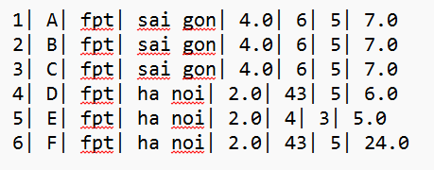
Output: screen after loading data
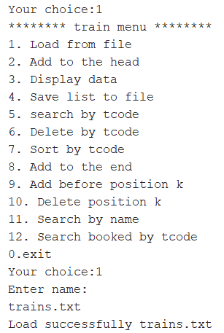

1.2. Input and Add to the end
Input: screen enter data
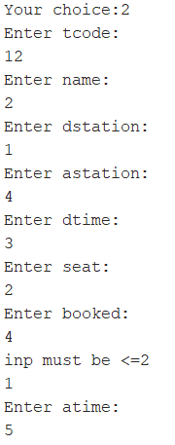

Output: screen after entering data
After display:
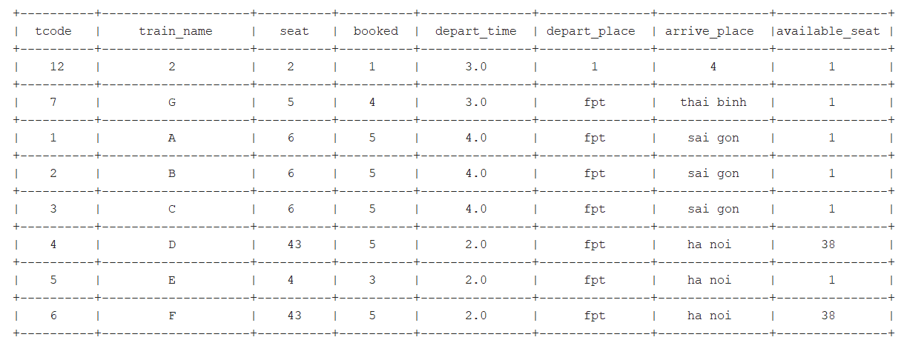
1.3. Display data

Input: screen enter data
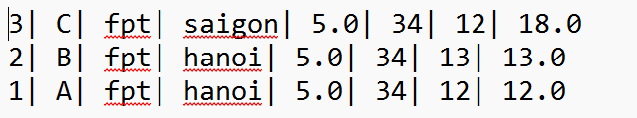
Output: screen after entering data
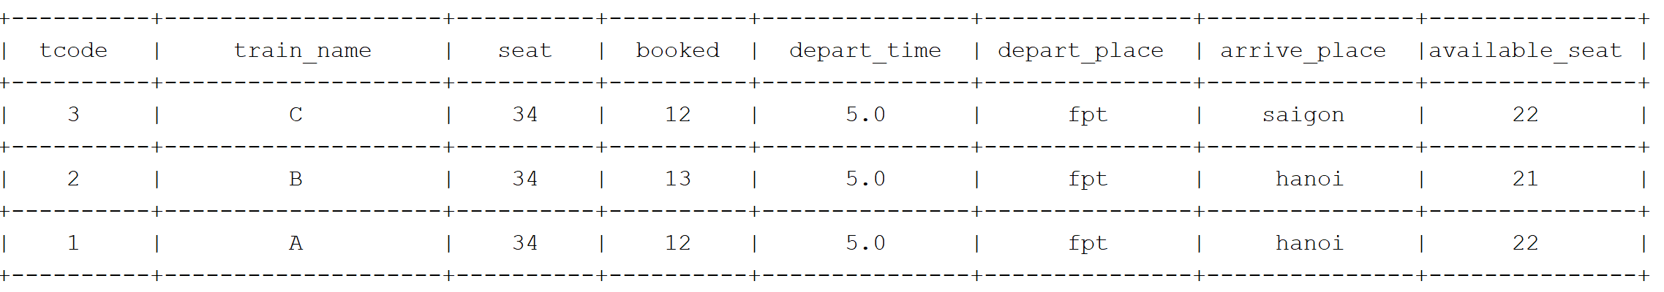

1.4. Save to file .txt (trains.txt)
Input: screen enter data
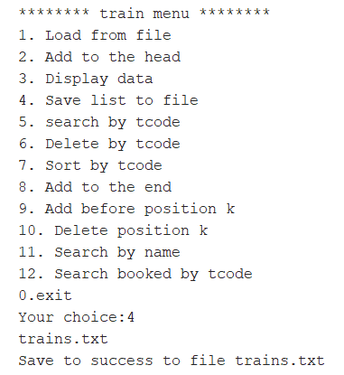
Output: screen after entering data
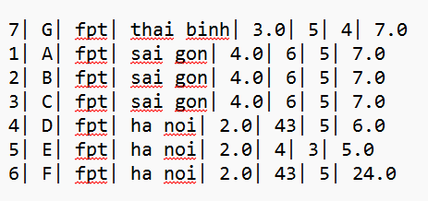
1.5. Search by tcode

Input: screen enter data
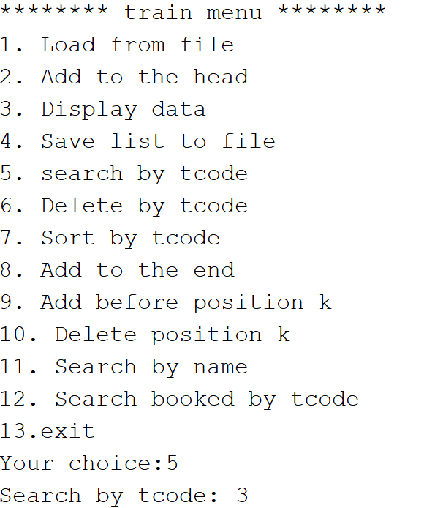
Output: screen after entering data
1.6. Delete by tcode

Input: screen enter data
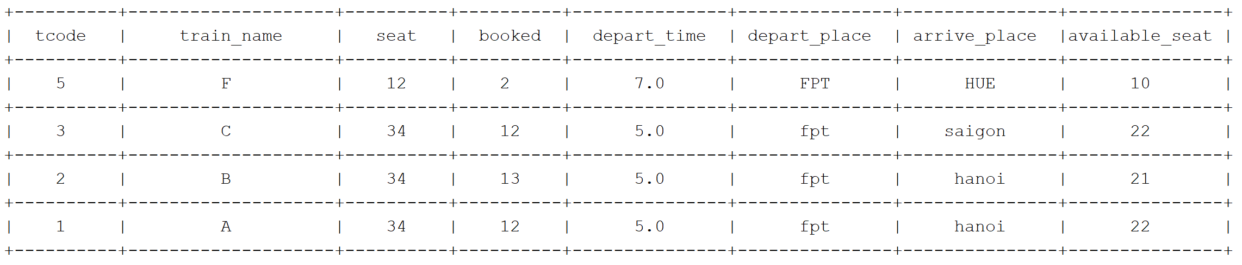
Output: screen after entering data
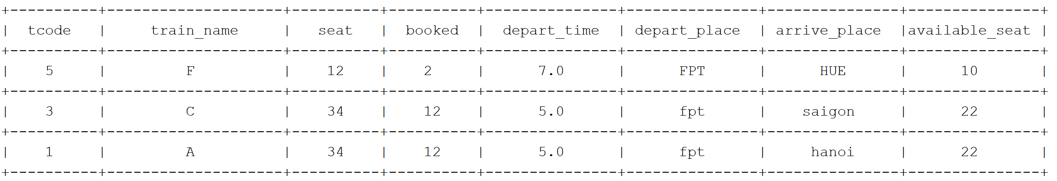
1.7. Sort by tcode

Input: screen enter data
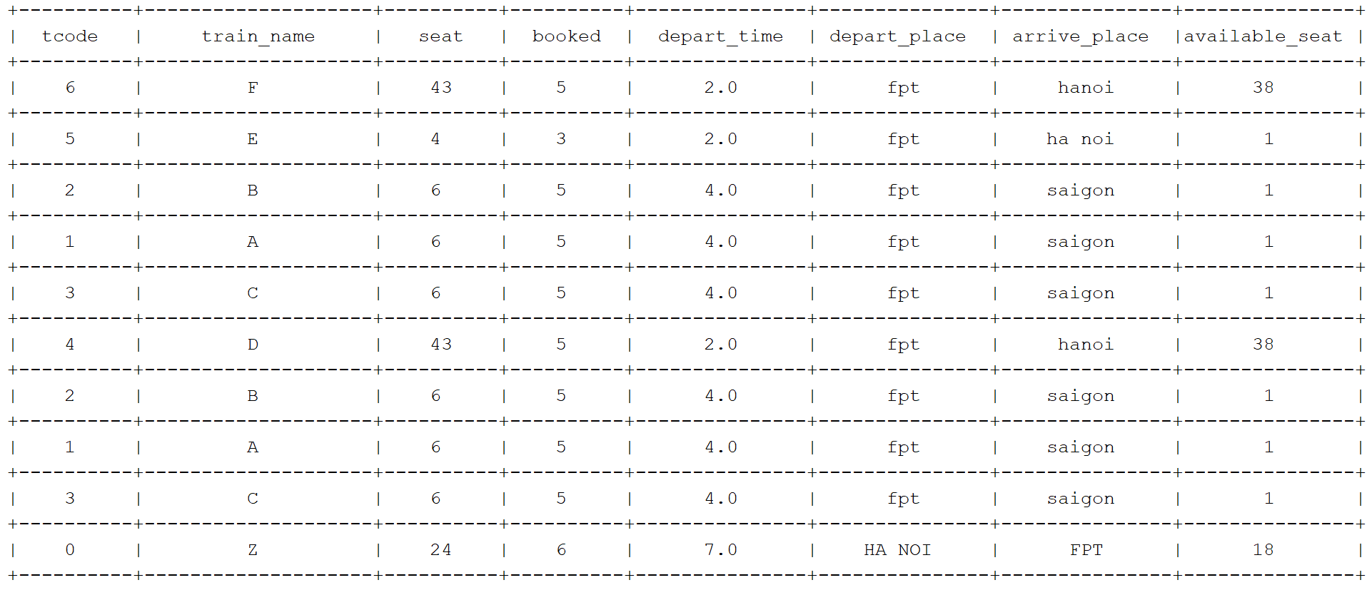
Output: screen after entering data
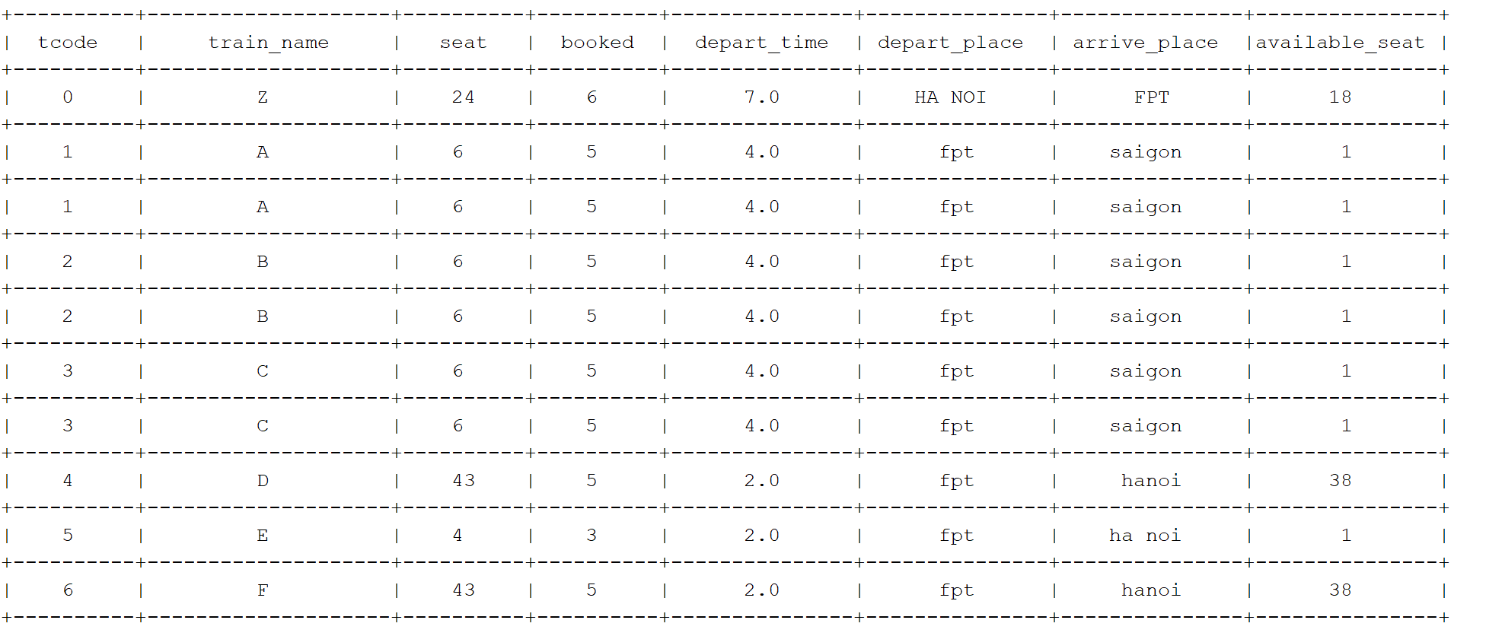
1.8. Input and Add to the beginning
Input: screen enter data
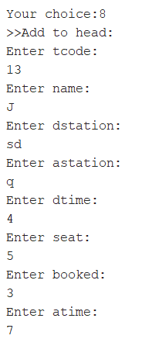
Output: screen after entering data
After display :
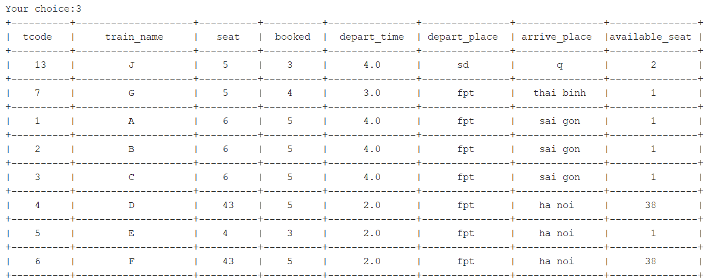
1.9 Add before position k
Input: screen enter data
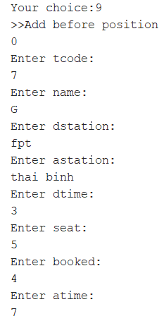
Output: screen after entering data
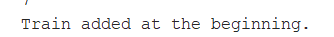
1.10. Delete position k
Input: screen enter data
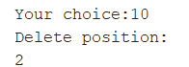
Output: screen after entering data
1.11. Search by name

Input: screen enter data
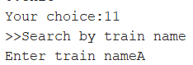

Output: screen after entering data
1.12. Search booked train by tcode and list all passengers who booked that train
Input: screen enter data
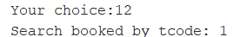
Output: screen after entering data
Begin (no passenger, no book):
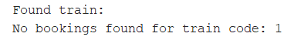
Train in book list, but no passengers take the train yet:
After passenger book train:
2. Passenger list
2.1. Load data from file
Input: data in file
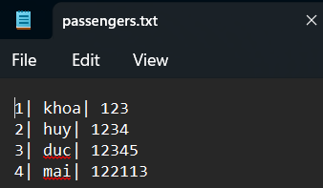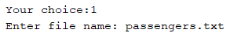
Output: screen after entering data

After display data:
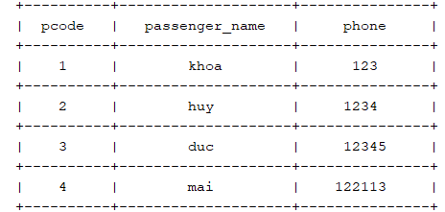
2.2. Input and Add to the end
Input: screen enter data
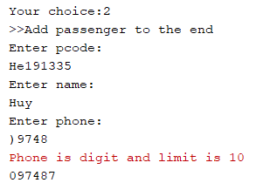
Output: screen after entering data
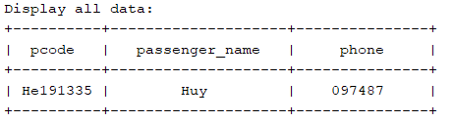
2.3. Display data
Input: screen enter data
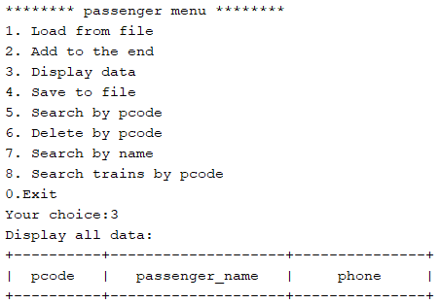
Output: screen after entering data
2.4. Save passenger list to file
Input: screen enter data
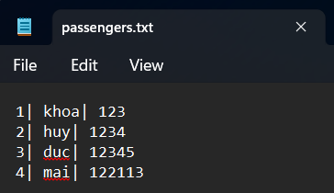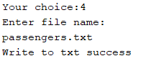
Output: screen after entering data
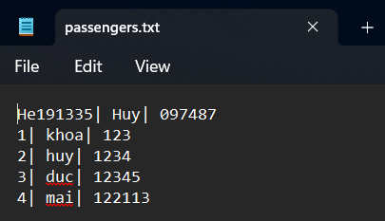
2.5. Search by pcode
Input: screen enter data
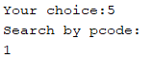
Output: screen after entering data
2.6. Delete by pcode
Input: screen enter data
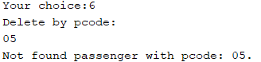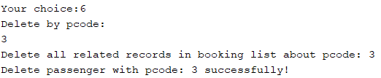
Output: screen after entering data
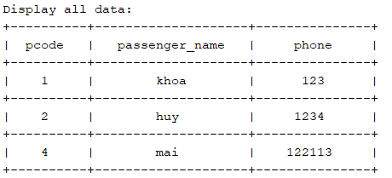
2.7. Search by name
Input: screen enter data
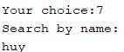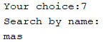
Output: screen after entering data
2.8. Search trains by pcode
Input: screen enter data

Output: screen after entering data
3. Booking list
3.1. Load data from file

Input: screen enter data
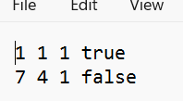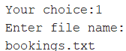

Output: screen after entering data

3.2. Book bus
Input: screen enter data
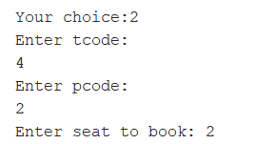
Output: screen after entering data
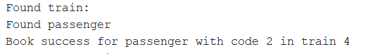
3.3. Display data
Input: screen enter data + Output: screen after entering data
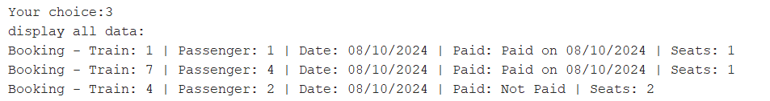
3.4. Save booking list to file
Input: screen enter data + Output: screen after entering data
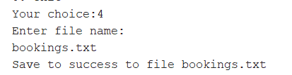
3.5. Sort by tcode + pcode
Input: screen enter data + Output: screen after entering data
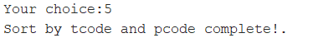
Display after sort:
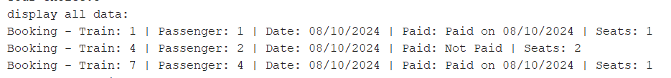

3.6. Pay booking by tcode + pcode
Input: screen enter data + Output: screen after entering data
Passenger has paid
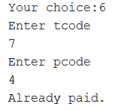
A paid from passenger
